

**Software Requirements Specification**

**for**

**Tourism Management System**

**Version 1.0 approved**

**Prepared by Shivam Pawar(2019230068)**

**Vishal Salvi(2019230069)**

**Shreyas Patel(2018130037)**

***Copyright © 1999 by Karl E. Wiegers. Permission is granted to use, modify, and distribute this document.***

***Software Requirements Specification for <Project>*** ***Page ii***

**Table of Contents**

|  |  |  |  |
| --- | --- | --- | --- |
| **Table of Contents ..........................................................................................................................** | | | **ii** |
| **Revision History ............................................................................................................................** | | | **ii** |
| **1.** | **Introduction ..............................................................................................................................** | | **1** |
|  | 1.1 | Purpose ............................................................................................................................................. | 1 |
|  | 1.2 | Document Conventions .................................................................................................................... | 1 |
|  | 1.3 | Intended Audience and Reading Suggestions................................................................................... | 1 |
|  | 1.4 | Product Scope ................................................................................................................................... | 1 |
|  | 1.5 | References......................................................................................................................................... | 1 |
| **2.** | **Overall Description ..................................................................................................................** | | **2** |
|  | 2.1 | Product Perspective .......................................................................................................................... | 2 |
|  | 2.2 | Product Functions ............................................................................................................................. | 2 |
|  | 2.3 | User Classes and Characteristics ...................................................................................................... | 2 |
|  | 2.4 | Operating Environment .................................................................................................................... | 2 |
|  | 2.5 | Design and Implementation Constraints ........................................................................................... | 2 |
|  | 2.6 | User Documentation ......................................................................................................................... | 2 |
|  | 2.7 | Assumptions and Dependencies ....................................................................................................... | 3 |
| **3.** | **External Interface Requirements ...........................................................................................** | | **3** |
|  | 3.1 | User Interfaces .................................................................................................................................. | 3 |
|  | 3.2 | Hardware Interfaces .......................................................................................................................... | 3 |
|  | 3.3 | Software Interfaces ........................................................................................................................... | 3 |
|  | 3.4 | Communications Interfaces .............................................................................................................. | 3 |
| **4.** | **System Features .......................................................................................................................** | | **4** |
|  | 4.1 | System Feature 1 .............................................................................................................................. | 4 |
|  | 4.2 | System Feature 2 (and so on)............................................................................................................ | 4 |
| **5.** | **Other Nonfunctional Requirements .......................................................................................** | | **4** |
|  | 5.1 | Performance Requirements ............................................................................................................... | 4 |
|  | 5.2 | Safety Requirements ......................................................................................................................... | 5 |
|  | 5.3 | Security Requirements ...................................................................................................................... | 5 |
|  | 5.4 | Software Quality Attributes .............................................................................................................. | 5 |
|  | 5.5 | Business Rules .................................................................................................................................. | 5 |
| **6.** | **Other Requirements ................................................................................................................** | | **5** |
| **Appendix A: Glossary....................................................................................................................** | | | **5** |
| **Appendix B: Analysis Models .......................................................................................................** | | | **5** |
| **Appendix C: To Be Determined List ............................................................................................** | | | **6** |

**Revision History**

|  |  |  |  |
| --- | --- | --- | --- |
| **Name** | **Date** | **Reason For Changes** | **Version** |
|  |  |  |  |
|  |  |  |  |
|  |  |  |  |
|  |  |  |  |

***Software Requirements Specification for <MTGMS>*** ***Page 1***

1. **Introduction**

**1.1** **Purpose**

This SRS describes the software functional and non-functional requirements for release 1.0 of the Mumbai tour guide and management system (MTGMS). This document is intended to be used by the members of the project team that will implement and verify the correct functioning of the system. Unless otherwise noted, all requirements specified here are high priority and committed for release 1.0.

**1.2** **Document Conventions**

When you read this SRS, certain words are represented in different fonts, typefaces, sizes, and weights. This highlighting is systematic; different words are represented in the same style to indicate their inclusion in a specific category. The types of words that are represented this way include the following:

**1.3** **Intended Audience and Reading Suggestions**

While the software requirement specification (SRS) document is written for a more general audience, this document is intended for individuals directly involved in the development of Tourism Management System. This includes software developers, project consultants, and team managers. This document need not be read sequentially; users are encouraged to jump to any section they find relevant.

**1.4** **Product Scope**

The Mumbai tour guide and management system (MTGMS) is an implementation of a managing Tourism website which helps the customers to search the availability and rent of various hotel rooms in particular places, along with the different packages available with the reservations. This project also covers various features like online registration of the users, history of tourism location, by adding, deleting or modifying the customer details or packages information. In general, this website would be designed to perform like any other Tourist management website available online.

**1.5** **References**

1. http://www.cse.iitd.ac.in/~cs5080212/Group08_(STUB)_SRS_Version_1.1.pdf
2. http://www.cse.chalmers.se/~feldt/courses/reqeng/examples/srs_example_2010_group2.pdf

***Software Requirements Specification for <Project>*** ***Page 2***

1. **Overall Description**

**2.1** **Product Perspective**

Access to relevant and accurate information is at the heart of tourism, more so in this era of the Internet information overload has become a prevalent phenomenon and as such a serious issue for those seeking for appropriate information. Tourism Management System tries to bridge the gap by nothing what a tourist perceives as relevant so, the aim of this is TMS will assist tourists in gaining access to information on tourist location in India as well as get reviews about that location or book nearby hotel to stay also can check the specification of hotel and book hotel.

Tourist Location Review

Tourist Location History

Nearby Hotel Booking

User Login

Tourism Management System

Hotel Review

Email Verification

**2.2** **Product Functions**

* User Login and authentication.
* Search Tourist Place- User can search best tourist place in Mumbai.
* Location Review- User can get reviews of that place from those who previously visited.
* User can view images of tour place as well as get history or information regarding location.
* Hotel Booking- If user want to stay in hotel then they can book room in hotel.
* Make Payment- After booking the room in hotel user can pay the room rent.

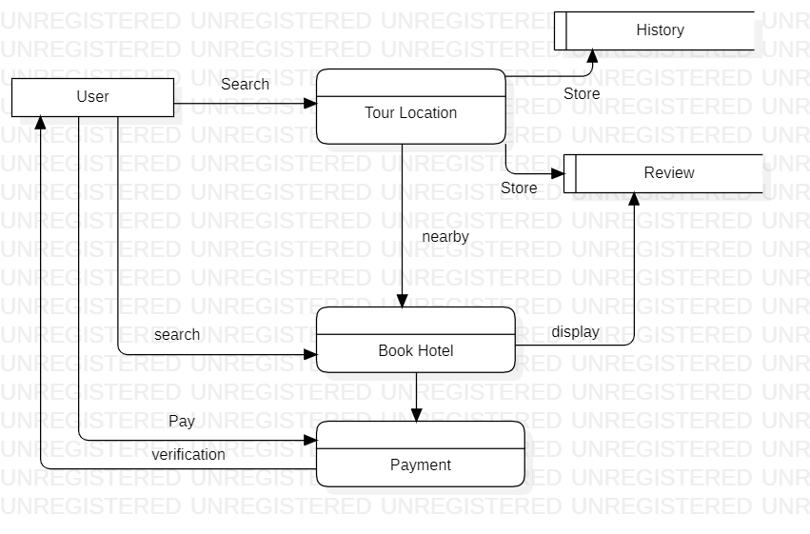

**2.3** **User Classes and Characteristics**

Tourist User: User can view details about tour location as well as use hotel system to book room.

**2.4** **Operating Environment**

The Mumbai tour guide and management system shall operate with all the Web browsers.

**2.5** **Design and Implementation Constraints**

CO-2: The system shall use MySQL database engine.

CO-3: All HTML code shall conform to the HTML 4.0 standard.

CO-4: All scripts shall be written in Python and Django

**2.6** **User Documentation**

UD-1: For new user system shall provide hierarchical structure so that user can get how to use web application

UD-2: The first time a new user access the system and on user demand therefore the system shall provide an online tutorial to allow to practice on how to get Mumbai tourist place history and information regarding same as well as hotel booking system

**2.7** **Assumptions and Dependencies**

AS-1: The system shall show of all the Mumbai tour guide and management system.

***Software Requirements Specification for <Project>*** ***Page 3***

1. **External Interface Requirements**

**3.1** **User Interfaces**

*<Describe the logical characteristics of each interface between the software product and the users. This may include sample screen images, any GUI standards or product family style guides that are to be followed, screen layout constraints, standard buttons and functions (e.g., help) that will appear on every screen, keyboard shortcuts, error message display standards, and so on. Define the software components for which a user interface is needed. Details of the user interface design should be documented in a separate user interface specification.>*

**3.2** **Hardware Interfaces**

*<Describe the logical and physical characteristics of each interface between the software product and the hardware components of the system. This may include the supported device types, the nature of the data and control interactions between the software and the hardware, and communication protocols to be used.>*

**3.3** **Software Interfaces**

*<Describe the connections between this product and other specific software components (name and version), including databases, operating systems, tools, libraries, and integrated commercial components. Identify the data items or messages coming into the system and going out and describe the purpose of each. Describe the services needed and the nature of communications. Refer to documents that describe detailed application programming interface protocols. Identify data that will be shared across software components. If the data sharing mechanism must be implemented in a specific way (for example, use of a global data area in a multitasking operating system), specify this as an implementation constraint.>*

**3.4** **Communications Interfaces**

*<Describe the requirements associated with any communications functions required by this product, including e-mail, web browser, network server communications protocols, electronic forms, and so on. Define any pertinent message formatting. Identify any communication standards that will be used, such as FTP or HTTP. Specify any communication security or encryption issues, data transfer rates, and synchronization mechanisms.>*

***Software Requirements Specification for <Project>*** ***Page 4***

1. **System Features**

*<This template illustrates organizing the functional requirements for the product by system features, the major services provided by the product. You may prefer to organize this section by use case, mode of operation, user class, object class, functional hierarchy, or combinations of these, whatever makes the most logical sense for your product.>*

**4.1** **System Feature 1**

*<Don’t really say “System Feature 1.” State the feature name in just a few words.>*

4.1.1 Description and Priority

*<Provide a short description of the feature and indicate whether it is of High, Medium, or Low priority. You could also include specific priority component ratings, such as benefit, penalty, cost, and risk (each rated on a relative scale from a low of 1 to a high of 9).>*

4.1.2 Stimulus/Response Sequences

*<List the sequences of user actions and system responses that stimulate the behavior defined for this feature. These will correspond to the dialog elements associated with use cases.>*

4.1.3 Functional Requirements

*<Itemize the detailed functional requirements associated with this feature. These are the software capabilities that must be present in order for the user to carry out the services provided by the feature, or to execute the use case. Include how the product should respond to anticipated error conditions or invalid inputs. Requirements should be concise, complete, unambiguous, verifiable, and necessary. Use “TBD” as a placeholder to indicate when necessary information is not yet available.>*

*<Each requirement should be uniquely identified with a sequence number or a meaningful tag of some kind.>*

REQ-1:

REQ-2:

**4.2** **System Feature 2 (and so on)**

1. **Other Non-functional Requirements**

**5.1** **Performance Requirements**

**PR-1:** The Mumbai tour guide and management system (MTGMS) application should be able to respond to the queries submitted by the customer without much delay.

**PR-2:** When a user searches for a tour location, the application should not take much time to return the results, similarly for the Hotel.

**PR-3:** Considering that the application is of moderate size, it should be able to display 5 results at a time on each page, when the customer looks up for any particular data.

**PR-4:** Since the Online tourism websites have much traffic, the user should also be able to logon to the system using high speed internet.

**PR-5:** Most of the requests sent to the application should be answered in less than 5 seconds.

**5.2** **Safety Requirements**

No safety requirements have been identified

* 1. **Security Requirements**

It must be ensured that access will be provided to the authorized persons through user ID and password.

Network security will be provided by the use of firewalls.

Checks can be performed at regular internals to ensure data integrity

**5.4** **Software Quality Attributes**

**Reliable:** For all services that rely on MTGMS for access control, lack of availability of the supported services. The product should not crash under any circumstance such as user entering invalid values, user trying to find unusual data etc. It should show appropriate message for every user generated message.

**Transparent:** Ideally, the user should not be aware that authentication is taking place beyond the requirement to enter a password.

**Scalable:** The system should be capable of supporting large number of client and servers. This suggests modular, distributed architecture

**Portable:** Our product will be portable to carry and will run in any machine provided it runs any Operating System.

**5.5** **Business Rules**

*<List any operating principles about the product, such as which individuals or roles can perform which functions under specific circumstances. These are not functional requirements in themselves, but they may imply certain functional requirements to enforce the rules.>*

***Software Requirements Specification for <Project>*** ***Page 5***

**5.2** **Safety Requirements**

*<Specify those requirements that are concerned with possible loss, damage, or harm that could result from the use of the product. Define any safeguards or actions that must be taken, as well as actions that must be prevented. Refer to any external policies or regulations that state safety issues that affect the product’s design or use. Define any safety certifications that must be satisfied.>*

**5.3** **Security Requirements**

*<Specify any requirements regarding security or privacy issues surrounding use of the product or protection of the data used or created by the product. Define any user identity authentication requirements. Refer to any external policies or regulations containing security issues that affect the product. Define any security or privacy certifications that must be satisfied.>*

**5.4** **Software Quality Attributes**

*<Specify any additional quality characteristics for the product that will be important to either the customers or the developers. Some to consider are: adaptability, availability, correctness, flexibility, interoperability, maintainability, portability, reliability, reusability, robustness, testability, and usability. Write these to be specific, quantitative, and verifiable when possible. At the least, clarify the relative preferences for various attributes, such as ease of use over ease of learning.>*

**5.5** **Business Rules**

*<List any operating principles about the product, such as which individuals or roles can perform which functions under specific circumstances. These are not functional requirements in themselves, but they may imply certain functional requirements to enforce the rules.>*

1. **Other Requirements**

*<Define any other requirements not covered elsewhere in the SRS. This might include database requirements, internationalization requirements, legal requirements, reuse objectives for the project, and so on. Add any new sections that are pertinent to the project.>*

**Appendix A: Glossary**

*<Define all the terms necessary to properly interpret the SRS, including acronyms and abbreviations. You may wish to build a separate glossary that spans multiple projects or the entire organization, and just include terms specific to a single project in each SRS.>*

**Appendix B: Analysis Models**

*<Optionally, include any pertinent analysis models, such as data flow diagrams, class diagrams, state-transition diagrams, or entity-relationship diagrams*.>

***Software Requirements Specification for <Project>*** ***Page 6***

**Appendix C: To Be Determined List**

*<Collect a numbered list of the TBD (to be determined) references that remain in the SRS so they can be tracked to closure.>*